**Creating Microservices for account and loan**

**Account**

**AccountController.java**

package com.cognizant.account.controller;

import org.springframework.web.bind.annotation.*;

import java.util.LinkedHashMap;

import java.util.Map;

*@RestController*

*@RequestMapping*("/accounts")

public class AccountController {

*@GetMapping*("/{accNo}")

public Map<String, Object> fetchAccountDetails(*@PathVariable*("accNo") String accNo) {

Map<String, Object> accountData = new LinkedHashMap<>();

accountData.put("accountNumber", accNo);

accountData.put("accountType", "current");

accountData.put("availableBalance", 512300);

return accountData;

}

}

**AccountApplication.java**

package com.cognizant.account;

import org.springframework.boot.SpringApplication;

import org.springframework.boot.autoconfigure.SpringBootApplication;

*@SpringBootApplication*

public class AccountApplication {

public static void main(String[] args) {

SpringApplication.*run*(AccountApplication.class, args);

}

}

**Output :**

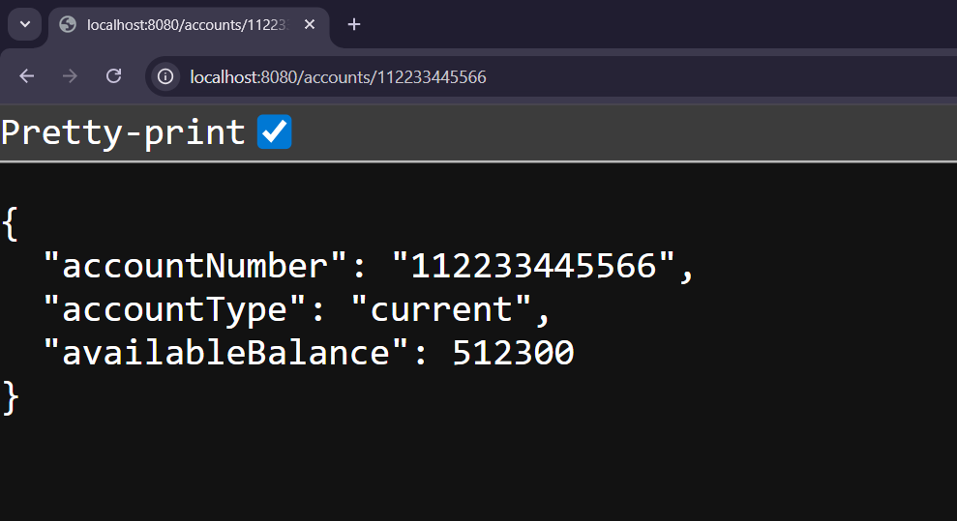

**Loans**

**LoanController.java**

package com.cognizant.loan.controller;

import org.springframework.web.bind.annotation.*;

import java.util.LinkedHashMap;

import java.util.Map;

*@RestController*

*@RequestMapping*("/loans")

public class LoanController {

*@GetMapping*("/{loanId}")

public Map<String, Object> fetchLoanDetails(*@PathVariable*("loanId") String loanId) {

Map<String, Object> loanInfo = new LinkedHashMap<>();

loanInfo.put("loanNumber", loanId);

loanInfo.put("loanType", "home");

loanInfo.put("loanAmount", 750000);

loanInfo.put("monthlyEMI", 5890);

loanInfo.put("durationMonths", 24);

return loanInfo;

}

}

**LoanApplication.java**

package com.cognizant.loan;

import org.springframework.boot.SpringApplication;

import org.springframework.boot.autoconfigure.SpringBootApplication;

*@SpringBootApplication*

public class LoanApplication {

public static void main(String[] args) {

SpringApplication.*run*(LoanApplication.class, args);

}

}

**Output :**

